Report on Enhanced Parking Lot Simulation:

**⚫ Vital information:**

U10P32002, School of Computer Science and Technology, NPU, Spring 2019

Written by Dikshya Kafle

2018380039

Programming Assignment 5 Due date: April 22

⚫ **Problem Statement**:

In this assessment the STL stack adapter, the STL vector container is to be used to find STL algorithm in order to solve the problem we are facing in the given program. Therefore, we are supposed to complete the program which stimulates a multiple-aisle parking lot. In the given program we are supposed to complete the implementation for stimulation to the file named main.cpp. The purpose of this task is to keep track of the each individual cars about that how many times individual cars are moved while handling the departure of other cars. In addition to that, alphabetized list of cars which visited the parking lot during the stimulation process is to be displayed. For this process we are being provided with the file data.txt with the arrival and departure data.

**⚫ Structure Chart** :

Main

Car&find_car

handle_arrival

handle_departure

getTimesMoved

getAisle

getPlate

setTimesMoved

bool operator <

bool operator ==

**⚫ Implementation**

In “main.cpp” we have 3 subprograms:

**Function :**

**Int main**

Vector function is being used in parking lot stimulation program instead of array because if we had used array it would not allow us to increase the size of the array whereas vector is known as dynamic array meaning it’s size can be increased. Therefore, the vector function is being used as seen throughout the program. The int main () function starts with the try function.

Furthermore, try function associates a sequence of catch clauses with the entire function body and with the member initializer list as well. Every excreption thrown from any statement in the function body, destructor, transfers control to the handler-sequence the same way an exception thrown in a regular try block would.

In this program try function which first opens the file “data.text” and if there is error the

**1.Subprogram name**: handle_arrival

**Parameters:** vector<Car>& cars, vector< stack<string> >& parking_lot, const string& plate

**Names and types of any parameters:** “find_car”-object, “asile” – int, “parking_lot”, “[departing.getAisle()”, “moving.setTimesMoved”, “moving.getTimesMoved”, temp.push, asile.top(), asile.pop()

**Input:** The purpose of this sub program is to find the car in the lot. The departing car is to be found. Therefore,

Therefore, the iteration size is entered and the procedure is being carried by using if else function.

**Output:** Print the car plates if not full and prints “Sorry the car lot is full” if the car lot is full.

**Algorithm**: Subprogram has two if statements one statement checks if the car lot is full or not the other statement is being proceeded after that where it check the car arrival plates. Else the output will be the parking lot is full. The main purpose of this section is to handle the car arrivals.

**2.Subprogram name:** **handle_departure**

**Names and types of any parameters**: “asile” – int, “parking_lot” – int, “parking_lot.end” –int, , departing.getAisle() , asile.top() , find_car , moving.setTimesMoved, moving.getTimesMoved(),temp.push(asile.top(),asile.pop

**Input:** Here we create a temp function for the cars to move and find the car we are looking for. The implementation of stack is being done by using parameters like asile.pop(), asile.push(), temp.top(), temp.pop().

**Asile. pop:** is to delete the top car of asile and decreasing the size of asile car by one.

**temp_push:** Add one car to the top of temp, increasing the size temp by one

**temp.empty**: return true if temp is empty (contains zero car): otherwise return false.

**temp.top():** return a reference (or const_reference) to the top component of temp.

**asile. push():** add value to the top of asile, increasing size by one.

**asile.top():** return a reference (or const_reference) to the top component of asile.

**Output:** the main function of this subprogram is to find the car in the lot. Therefore, when the departing car gets the plate i.e. “departing.getPlate” the program will output “the car was moved” and when the departing car gets the time moved i.e. “departing.getTimesMoved” then the output will be displayed as “time while it was here!”

**Algorithm:** This subprogram uses void function meaning no return type. The program has two while statements. The first while checks the plates when the asile. top() does not returns the reference to to the top of components. Similarly the second while function checks when temp file is not empty.

**3. Subprogram name: Car&find_car**

**Parameters:** vector<Car>& cars, string plate

**Input:** Iterators are used to point at the memory addresses of [STL](http://quiz.geeksforgeeks.org/the-c-standard-template-library-stl/) containers. They are primarily used in sequence of numbers, characters etc. They reduce the complexity and execution time of program.

**Operations of iterators**:

**cars.begin()** :- This function is used to return the **beginning position** of the container.

**cars.end()** :- This function is used to return the***after* end position** of the container.

**Output:** The program returns to the pointer car. Therefore, this subprograms returns a reference to the car whose license plate equals the parameter plate.

**⚫ Test Description and Results**:

The following is the result of the enhanced parking lot stimulation. I created a project in the code blocks and added main.cpp file which I had written. Afterwards I opened an empty file on it and copied and pasted a file named car.h from the given assignment 6 handouts. Similarly, I did the same for file car.cpp. After adding all three files in the project. I opened the project folder and added the data.txt file. After this ran the program and the results were displayed as the followings:

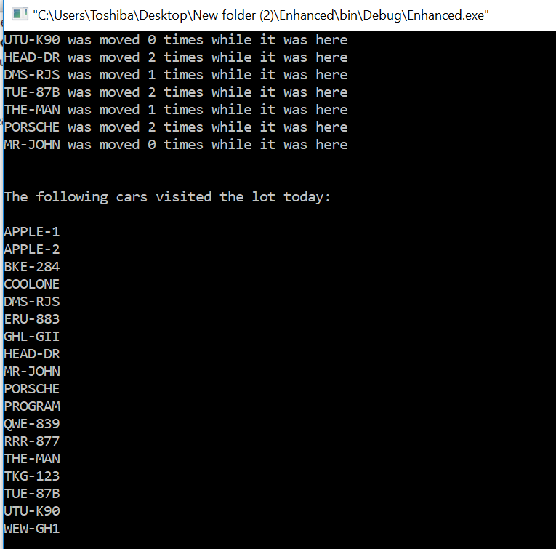

The result shows how many times different car were being moved while they were in the parking lot. In addition to that all the license plate of the cars which visited in the parking lot were also displayed. It is clearly seen in the above screenshots.

**⚫ Epilogue** – While doing the program I had many bugs which had influence on program’s working and many troubles with compilation programs, because of syntax. However, the biggest problem I faced for several days was in opening the data.text file. I had problem in opening the file data.txt. Everytime I tried running the program it displayed “data.txt can not be opened”. After checking on the internent I figured out that my syntax was not correct. After having the knowledge of the ifstream function I wrote the correct code. However, it still failed to open the file again and figured out that the parameters inside the int main function was creating the problem i.e “(int argc, char* argv[]) “ and after removing that I could actually run the program properly. I had to be stuck on this thing for very long time. The moment when I figured out the solution I was really very happy. This programming is very time consuming and very hard topic for me. However, I managed to do with the help of a lot of You Tube videos, blogs and websites. This program helped me understand the use of STL stack adapter, the STL vector container. In addition to that, it helped me to understand the algorithm of a parking lot which is very interesting.

**⚫ Attachments**: The file main.cpp is being attached in the email. And this is the report file.

**⚫ Acknowledgement**:I wanted to discuss with students but whoever I asked they said they didn’t understand and were not willing to discuss. So, I had to suffer alone. I had to search a lot of stuffs in the internet to understand very basics of it. It was a very hard task for me. I have spent many days on doing this but I don’t really understand things much. Although I have spent many hours without giving time to other subjects. Discussing with friends would help a lot but it’s hard to find such environment here which is sad. I would like to thank You Tube and a lot of websites for helping me understand what I have done in this report. Later one I got chance to discuss something with Amir (he is also a student in the same class) which did brought change in my programming. I would like to thanks Amir for giving his few minutes in explaining things to me.